Working Group Business Case

Submitted by: Brighthouse Financial

Executive Summary:
This business case proposes the modernization of In-Force Transactions (IFT) by transitioning from XML-based messaging to RESTful APIs, as supported by industry vendors. The current XML technology, rooted in legacy SOAP infrastructure, is approaching end-of-life and lacks the scalability, flexibility, and security required by today’s digital ecosystems.

As the financial services industry evolves toward seamless, real-time, and lightweight digital experiences, REST APIs have emerged as the de facto standard due to their efficiency and ease of implementation. This initiative aligns directly with the IRI Digital First goals—prioritizing modern, secure, interoperable technology to ensure continued support and growth of the annuity and retirement markets.

Upgrading IFT transactions now prepares the industry to meet demands for speed, transparency, and integration, especially with the rise of microservices and event-driven architectures.

Problem:
The current IFT solution, which relies on XML and SOAP, presents several technical and operational challenges:

End-of-Life Technology:
- Legacy Systems: SOAP is no longer used and maintained
- Vendor & Community Support: Modern cloud provides prioritize REST/JSON
- Security Risks: Older SOAP implementation does not support OAuth 2.0
Lack of Scalability
- Verbose Payloads: XML is inherently bloated increasing bandwidth and processing overhead
- Complex Parsing: Slow to parse and impacts real-time processing
Complex
- Steep Learning Curve: SOAP requires understanding of WSDL, WML scheme and SOAP envelopes
- Integration Complexity: Cumbersome to integrate into microservices or serverless architecture
Flexibility
- Swagger/OpenAPIs are preferred by Carriers/Distributors for 3rd party integration
Objectives and Key Results
Objective: Modernize the IFT infrastructure to ensure continued functionality, future readiness, and alignment with the Digital First vision.
Key Results:
- Transition all IFT processing from XML to RESTful API architecture.
- Reduce transaction payload size and processing time by adopting lightweight data formats (e.g., JSON).
- Improve integration velocity across firms and carriers through standardized, easily adoptable APIs.
- Strengthen transaction security by implementing modern protocols (e.g., OAuth 2.0).
- Ensure long-term vendor and community support for the underlying technology stack.

Journey Maps (Integrations and Required Data)
The intention is to update all In-Force Transactions, including Inquiry, Withdrawal, Arrangements, Fund Transfers and non-financial. The Journey Map below covers inquiry and withdrawal only, but can be duplicated as each transaction is addressed.
Inquiry and Withdrawal Transaction Journey Map
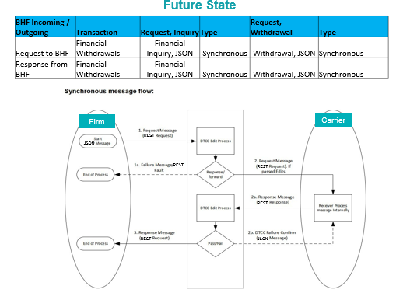

Solution
To modernize the IFT solution, Brighthouse Financial proposes a collaborative approach with the Digital First working group to align on a gap analysis, leverage Brighthouse’s existing payloads, and contribute the resulting work to IRI API library for broader industry benefit.

Feature 1: RESTful API Framework for IFT Transactions
- What it delivers: A modular, scalable suite of RESTful APIs using JSON payloads and OAuth 2.0 authentication.
- Why it matters: Enables real-time, secure, and lightweight data exchange—eliminating the limitations of legacy XML/SOAP systems.
Feature 2: OpenAPI/Swagger Documentation
- What it delivers: Developer-friendly specifications with clear schemas, endpoints, and integration guides.
- Why it matters: Reduces onboarding time, simplifies third-party integration, and ensures consistency across carriers and distributors.
Feature 3: Accelerated Development via Brighthouse Payloads
- What it delivers: Reuse of validated payload structures to fast-track API design and testing.
- Why it matters: Minimizes rework, ensures alignment with real-world use cases, and shortens time-to-market.
Feature 4: Open Contribution to IRI Standards
- What it delivers: A shared, governed repository of API standards hosted by IRI.
- Why it matters: Promotes interoperability, transparency, and long-term sustainability across the annuity and retirement ecosystem.
Feature 5: Standardized Testing Framework via Swagger Integration
- What it delivers: A shared Swagger-based testing environment embedded with representative test data from participating firms and carriers. This includes mock servers, sample payloads, and validation scripts aligned with the OpenAPI specification.
- Why it matters: Accelerates implementation by enabling early and consistent testing across stakeholders. It ensures interoperability, reduces integration errors, and builds confidence in the solution before full-scale deployment.

Timeline for Implementation
Phase 1: Planning & Kickoff (TBD)
- Kickoff Session: Align on goals, resources, and responsibilities.
- Business Case Development: Finalize the business case for stakeholder approval.
- Workstream Mapping: Define key tasks and related to-dos.
Phase 2: Standard Development (TBD)
- Working Group: Aligns on business requirements and data elements.
- Technical Committee: Create the technical spec in Github repository.
- Working Group: Business feasibility testing.
- Technical Committee: Technical feasibility testing.
Phase 3: Governance: (TBD)
- Governance Committee: Reviews the standard.
- Working Group & Technical Writers: Address any proposed revisions or updates.
- Governance Committee: Deploys the standard to Github.
Phase 4: MVP Development & Integration (TBD)
- Platform Development: Build the minimum viable product (MVP), focusing on beneficiary data updates.
- Carrier Integration: Work with at least three carriers for integration.
- User Testing: Conduct testing with a limited user base for feedback and adjustments.
Phase 5: Testing & Launch (TBD)
- Platform Testing: Perform full-scale testing, including functional and user acceptance testing.
- Platform Launch: Go live with the MVP and monitor initial performance.
Ongoing Support & Iteration (TBD)
- Continuous Monitoring: Address any issues or bugs post-launch.
- Iterative Improvements: Plan for additional features or scaling as needed.
- Track Implementation of standards on IRI’s Digital First Dashboard.
- Track Measures of Success to report on IRI’s Digital First Dashboard.
Working Group Firms:
Brighthouse Financial, DTCC, Distributor TBD

